Ivo Nilsson - SELECTED WORKS
Orchestra
Title: More objects with destinations
Year of composition: 2009
Instrumentation: Orchestra 2222-221-Timp.1 perc-Strings
Duration: 8´
Date of first performance: 2009-09-30
Place of first performance: Teatro alle Tese, La Biennale di Venezia
Ensemble: Orchestra di Padova e del Veneto, cond. Renato Rivolta
Download a programme note
-as a word file (in English)
-as a pdf file (in English)

Title: Rikoschett (composed together with Jonny Axelsson)
Year of composition: 2007
Instrumentation: trombone, percussion & string orchestra
Duration: 25´
Date of first performance: 2007-09-27
Place of first performance: Växjö, Konserthuset
Ensemble: Ivo Nilsson, Jonny Axelsson, Musica Vitae, cond Michael Bartosch
Download a programme note
-as a word file (in Swedish)
-as a pdf file (in Swedish)
Rikoschett is recorded on the Chamber Sound cd CSCD 10042:
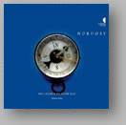>>Buy the record
Title: Torso
Year of composition: 2004
Instrumentation: orchestra -- 3*3*4*3* 4321 12 1 str, pf
Duration: 10´
Date of first performance: 2004-10-22
Place of first performance: Venezia, Teatro Malibran (48. festival internazionale di musica contemporanea)
Ensemble:Orchestra dell' Arena di Verona, dir Paul Manns
Download a programme note
-as a word file (in Enlish)
-as a pdf file (in English)

Title: IXOIDI
Year of composition1996
Instrumentation: Wind orchestra -- 3*3*4*3* 4321 12 1 str, pf
Duration:17´
Date of first performance:1996-10-22
Place of first performance: Stockholm New Music, Berwaldhallen
Ensemble:Stockholms blåsarsymfoniker, dir Jin Wang

Title:La chûte
Year of comp:2002-2003
Instrumentation:p orchestre de flûtes -- 4-8-4-4-4
Duration:10´
Premiered: 2003-12-04
Place:Paris, Salle Cortot
Performers: Orchestre de Flûtes Francais, dir André Chini

Music Drama
Title: RED DOC
Year of composition: 2022-23
Instrumentation:
6 actors + bass clarinet, trombone, theorbo/guitar, harp, contrabass
Duration: Total duration 1 hour, 56 min. Instrumental version 47”
Date of first performance: 2023-02-03
Place of first performance: Accelerator, Stockholm
Listen :
https://acceleratorsu.art/evenemang/radioart-red-doc/
Title: Il canzoniere del Barone Rampante
Year of composition: 2013-14
Instrumentation:
countertenor, recorders/barockoboe/oboe da caccia, theorbo/oud, cembalo/organ, violin, viola da gamba
Duration: Flexible, total duration 45´
Date of first performance: 2014-
Place of first performance: Medelhavsmuseet, Stockholm
Ensemble:Ensemble Lipparella with the countertenor Mikael Bellini
Watch a video:
-complete version
-short version
Read a review of the performance (in Swedish only).

Chamber ensemble, conducted
Title: Matematik à la Satane

Text: Nelly Sachs

Year of composition: 2015-19

Instrumentation: soprano, fl, clar, piano, vln, vlc

Duration: 16´

Date of first performance: 2019-09-27

Place of first performance: Forum för levande histora, Stockholm

Ensemble: Ensemble MA, soprano. Alexandra Büchel, cond. Staffan Larson

Released on the CD: https://bluemusicgroup.bandcamp.com/album/lunaria

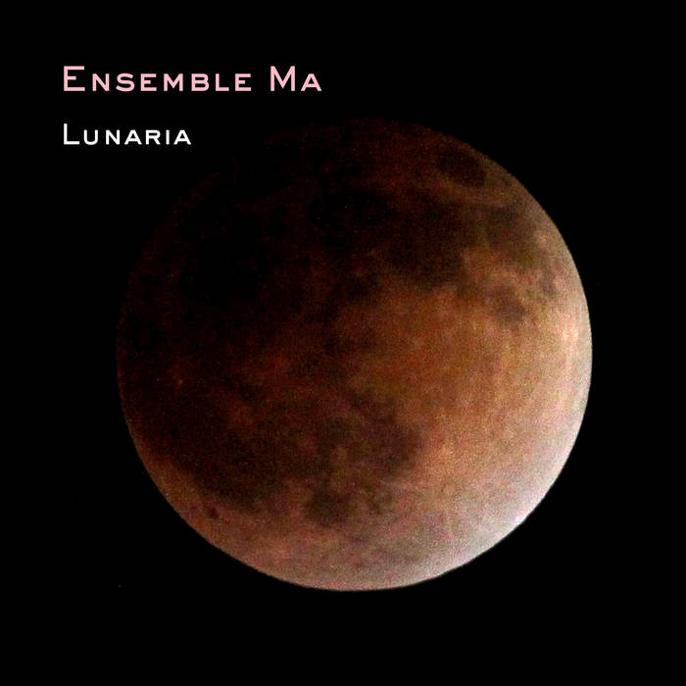

Title: Anacrusi

Year of composition: 2016

Instrumentation: fl,sax,piano,violin,cello,feedback conducting

Duration: 10´

Date of first performance: 2016-06-28
Place of first performance: Centro Galego de Arte Contemporanea, Santiago di Compostela, Spain
Ensemble:Vertixe Sonora, cond. Ramón Souto
Download a programme note
-as a word file (in English)
-as a pdf file (in English)
Title: Rapiditá
Year of composition: 2014-2015
Instrumentation: fl,cl,tbn,piano,vln,vla,vlc,cb
Duration: 8´
Date of first performance: 2015-01-30
Place of first performance: CBSO Centre, Birmingham
Ensemble: Birmingham Contemporary Music Group. Cond. Franck Ollu
Download a programme note
-as a word file (in English)
-as a pdf file (in English)
Title: Doppler Wobbler Subtile:Double concerto for viola, bassoon and 9 instruments
Year of composition: 2011-2012
Instrumentation: fl,cl,bsn,trp,hrn,piano,2vln,vla,vlc,cb
Duration: 16´
Date of first performance: 2012-02-10
Place of first performance: Chiffren festival, Kiel
Ensemble: KammarensembleN, Cond. Franck Ollu
Download a programme note
-as a word file (in English)
-as a pdf file (in English)
Doppler Wobbler is released on the CD: https://bluemusicgroup.bandcamp.com/album/4
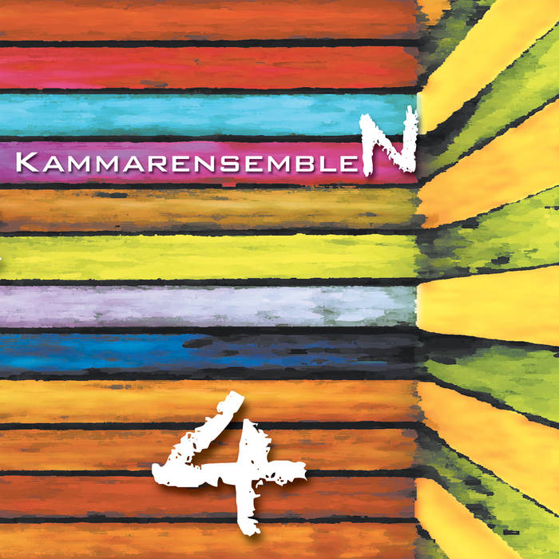

Title: NEJD
Year of composition: 2010
Instrumentation: voices: 3 sopranos,3 altos, tenor, baritone, bass + fl,cl,trp,hrp,vibr,mar,vln,vlc,cb
Duration: 23´
Date of first performance: 2010-10-08
Place of first performance: Connect festival, Palladium, Malmö
Ensemble: Vokalharmonin & KammarensembleN
Download a programme note
-as a pdf file (in Swedish and English)

Title: Lunaria
Year of comp: 2007-08
Instrumentation:Soprano, flute, clarinet, violin, cello and bass cimbalon (alt. piano)
Duration: 15´
Premiered:2008-02-23
Place: Musikmuseet, Stockholm
Performers: Ensemble MA, soprano Ibba Andersson, conductor Staffan Larson
Lunaria is released on CD at: https://bluemusicgroup.bandcamp.com/album/lunaria
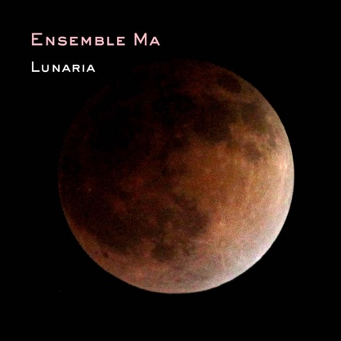

Title: Outbound
Year of comp:2005
Duration: 10´
Instrumentation:f wind quintet, string quartet & cb
Premiered:2005-07-04
Place: Zagreb, Croatia
Performers: Cantus, dir Berislav Sipus

Title: Rotorelief
Text:Duchamp, Marcel
Language: French
Year of comp:2001
Instrumentation:f spoken voice and chamber ensemble -- 1111 1110 01 1 str, pf
Duration:60´
Premiered:2001-11-10
Place: Kulturhuset, Stockholm
Performers: KammarensembleN, dir B Tommy Andersson
Rotorelief is recorded on the SFZ records cd SFZ 1006:
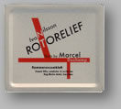>>About the record
>>Buy the record
Title: Rotorelief, Suite
Year of comp:2001
Instrumentation: chamber ensemble -- 1111 1110 01 1 str, pf
Duration:15´
Premiered:2003
Place:Warsaw automn, Polish Radio
Performers:KammarensembleN, dir Renato Rivolta
Download a programme note
-as a word file (in English)
-as a pdf file (in English)

Title:Totentanz
Year of composition:1993-1994
Instrumentation:f Kammerensemble -- 1*1*1*0 1110 10 0 2vl, vla, vlc, cb, sax
Duration:12´
Year of publication:2000
Date of first performance:1994-04-08
Place of first performance: Stockholm, Kulturhuset
Ensemble: KammarensembleN, dir B Tommy Andersson
Download a programme note
-as a word file (in Swedish)
-as a pdf file (in Swedish)

Totentanz is recorded on the Phono Suecia cd PSCD 120:
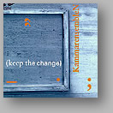>>Buy the record
Title: Eidetics
Year of comp: 1991
Instrumentation: f chamber ensemble -- ob, cl, fag, bar-sax, tr, trb, vl, vla, vlc, cb, 2perc, live-elektronik
Duration: 10´
Premiered:1991-12-07
Place: Stockholm, Radiohuset
Performers:KammarensembleN, dir Ansgar Krook

Title: Per-cept : sestetto
Year of comp:1989-1991
Instrumentation: fl/a-fl, ob/cor i, s-sax/a-sax, a-trb/t-trb, slagverk, piano, viola/violin
Duration:15´
Premiered: 1990-05-29
Place: Stockholm, Musikaliska Akademien
Performers:
Magnus Irving, Helén Jahren, Pierre-Stephane Meugé, Ivo Nilsson, Marcus Leoson, Love Derwinger, Fredrik Anderberg, dir Jonas Dominique

Title: Agnosi

Year of comp:1988
Instrumentation: pour hautbois, saxophone, trompette, harpe et quatuor à cordes
Duration:9´
Premiered: 1989-03-07
Place: Paris, Radio France
Performers:Ensemble L'Itinéraire
Download a programme note
-as a word file (in Swedish)
-as a pdf file (in Swedish)

Chamber ensemble, without conductor
Title: Hereabouts
Year of composition: 2012-13
Instrumentation: Saxophone, Trombone, Guitar, Cimbalom, Piano, Vibraphone, Violin & Cello
Duration: 15´
Date of first performance: 2013-10-03
Place: Lippes Concert Hall in Slee Hall, Buffalo, USA
Performers:Ensemble Son & Either/Or
Title: Apnea
Year of comp: 2004
Instrumentation:p quintetto di fiati -- fl, ob, cl, cor, fag
Duration: 9'
Premiered: 2004-10-10
Place: Ljubljana, Slovenian Radio
Performers: Slowind
Download a programme note
-as a word file (in English)
-as a pdf file (in English)
Title: Anomale
Year of comp:2002
Instrumentation: f kammarensemble -- fl, ob, cl, perc, pf, vl, vla, vlc
Duration: 5'
Premiered: 2003-11-30
Place: Freiburg, SWR
Performers: Ensemble Recherche
_______________________________________
Title: Whereabouts
Year of composition: 2017-18
Instrumentation: Mezzosoprano, trombone, 3 percussion, 2 violins, cello
Duration: 28´
Date of first performance: 2018-12-01
Place of first performance: Göteborgs Konshall, Gothenburg
Ensemble:DuoNow: UmeDuo, Duo Ego, Duo Gelland, Axelsson & Nilsson-Duo

Title: Whereabout 1
Year of composition: 2017-18
Instrumentation: cello & percussion
Duration: 12´
Date of first performance: 2018-03-09
Place of first performance: Grünewaldsalen, Konserthuset, Stockholm
Ensemble: UmeDuo
Released on CD: NEOS 12002

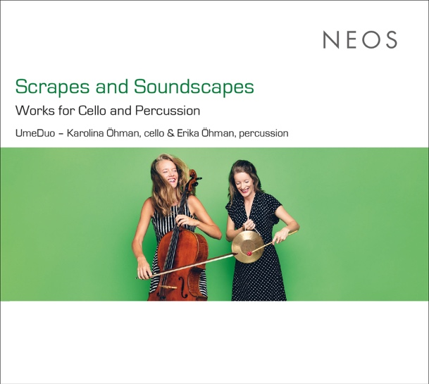
_____________________
Title: Whereabout 2
Year of composition: 2017-18
Instrumentation: mezzosoprano & percussion
Duration: 15´
Date of first performance:
2018-12-01
Place of first performance: Göteborgs Konsthall, Gothenburg
Ensemble: DuoEgo
_______________
Title: Whereabout 3
Year of composition: 2017-18
Instrumentation: Violin duo
Duration: 15´
Date of first performance: 2018-12-01
Place of first performance: Göteborgs Konsthall, Gothenburg
Ensemble:Duo Gelland
_______________________
Title:Whereabout 4
Year of composition: 2017-18
Instrumentation: trombone & percussion
Duration: 15´
Date of first performance: 2018-12-01
Place of first performance: Göteborgs Konsthall, Gothenburg
Ensemble: Axelsson & Nilsson-Duo
Download a programme note
-as a pdf file (in Swedish)

Chamber music

Title: SMOG
Year of composition: 2019
Instrumentation: Clarinet, Piano, Percussion, Violin
Duration: 11´
Date of first performance: 2019-10-03
Place: Zepernick, St. Annen kirche, Berlin

Performers:Kwartludium

Title: FOG

Year of composition: 2021

Instrumentation: Clarinet, Piano

Duration: 11´

Date of first performance: 2022-03-19

Place: Teater Giljotin, Svensk Musikvår

Performers: Stefan Harg, Katarina Harg

Title: CONTRARIA

Year of composition: 2020

Instrumentation: Horn & Trombone

Duration: 11´

Date of first performance: 2020-03-19

Place: Musikens Hus, Katrineholm

Performers: Sören Hermansson, Ivo Nilsson

video: https://www.youtube.com/watch?v=kFO6LXwnI1Y

Title: Controra
Year of composition: 2016
Instrumentation: Oboe, Trombone, Violoncello
Duration: 15'30
Commissioned by Das Orchester with support from the Swedish Arts Council
Date of first performance: 2017-02-08
Place of first performance: Hedengrens Bokhandel, Stockholm
Ensemble:Das Orchester
Controra is recorded on the label Blue Music Group.
Title: CONTRARPA

Year of composition: 2020

Instrumentation: HARP solo

Duration: 12´

Date of first performance: 2020-03-20

Place: Studio Lederman, Svensk Musikvår

Performers: Laura Stephenson

video: https://www.youtube.com/watch?v=cxpZvUKpoHw
Title: AREA d´ARIA
Year of composition: 2016
Instrumentation: Trombone, electronics and video
Duration: 11'
Date of first performance: 2016-11-22
Place of first performance:Alessandria, Conservatorio Antonio Vivaldi
Ensemble: Ivo Nilsson
>>Watch video

Title: Eppur si Muove
Year of composition: 2014-15
Instrumentation: Percussion, Trombone, Electronics and Video
Duration: 15'30
Date of first performance: 2015-04-24
Place of first performance: 3:e våningen, Gothenburg
Ensemble: Axelsson & Nilsson-Duo
>>Watch video

Title: Sylfer
Year of composition: 2020
Instrumentation: Percussion, Trombone
Duration: 6´
Date of first performance: 2020-05-14
Place of first performance: Sigtuna stiftelsen
Ensemble: Axelsson & Nilsson-Duo
>>Watch video
Title: Salicet
Year of composition: 2020
Instrumentation: clarinet and video
Duration: 9'
Date of first performance: 2022-12-04
Place of first performance: Festival di Musica Contemporanea di Bolzano
Ensemble:Roberta Gottardi
Download a programme note
-as a word file (in English)
-as a pdf file (in English)
Title: Gedeckt
Year of composition: 2008-09
Instrumentation: alto flute and electronics
Duration: 15'
Date of first performance: 2009-07-17
Place of first performance: Berlin, COMA Centre for opinions in music and arts
Ensemble:Erik Drescher
Download a programme note
-as a word file (in English)
-as a pdf file (in English)
Watch a video from a performance in Rome, Italy, January 2015:
-Gedeckt
Title: Objects with destinations
Year of composition: 2008
Instrumentation:
soprano,clarinet, contrabassoon, bass saxophone,trumpet, piano, vibraphone, marimba,violin, viola, cello, doublebass
Duration: 4´
Date of first performance: 2008-10-11
Place of first performance: Moderna Museet, Stockholm
Ensemble:KammarensembleN
Title: Object with destination 3
Year of composition: 2008
Instrumentation: contrabassoon, bass saxophone, marimba, viola
Duration: 4´
Date of first performance: 2008-10-11
Place of first performance: Moderna Museet, Stockholm
Ensemble: KammarensembleN
Title: Object with destination 2
Year of composition: 2008
Instrumentation: soprano, trumpet, piano, doublebass
Duration: 4´
Date of first performance: 2008-10-11
Place of first performance: Moderna Museet, Stockholm
Ensemble:KammarensembleN

Title: Object with destination 1
Year of composition: 2008
Instrumentation: clarinet, vibraphone, violin, cello
Date of first performance: 2008-10-11
Place of first performance: Moderna Museet, Stockholm
Ensemble: KammarensembleN
------------------
Title: 5 actions
Year of composition: 2008
Instrumentation: percussion duo
Duration: 12´
Date of first performance: 2008-09-26
Place of first performance: Pusterviksteatern, Gothenburg
Ensemble:Amund Sjölie Sveen, Yi-Ping Yang
------------------
Title:Toccata
Year of composition: 2007
Instrumentation: per sestetto di percussionisti
Duration: 14'
Date of first performance: 2009-10-03
Place of first performance: ISCM World New Music Days, Artisten Göteborg
Ensemble: Kroumata
Download a programme note
-as a word file (in Swedish)
-as a pdf file (in Swedish)
Title: Doppelzimmer
Year of composition:2006
Instrumentation:accordion and double-bass
Duration: 10´
Date of first performance: 2006-11-26
Place of first performance: Kulturbahnhof Eller
Ensemble:Slide Show Secret
Download a programme note
-as a word file (in English)
-as a pdf file (in English)
Title:Diabas
Year of comp: 2005
Instrumentation:p bassoon and base cimbalon
Duration:13´
Premiered: Recording released June 2006
Performers:
Knut Sönstevold, Jonny Axelsson
Download a programme note
-as a word file (in Swedish)
-as a pdf file (in Swedish)
Diabas is recorded on the Phono Suecia cd PSCD 164:
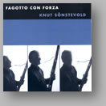>>Buy the record
Title:Sotto vuoto
Year of comp:2003
Instrumentation:p sassofono tenore e trombone
Duration:12´
Premiered: 2003-10-30
Place: Rome, Hungarian Academy (Nuovi Spazi Musicali)
Performers: Jörgen Pettersson, Ivo Nilsson
Download a programme note
-as a word file (in Swedish and English)
-as a pdf file (in Swedish and English)

Title: Luta
Year of comp:1999-2000
Instrumentation:f teorb
Duration:12´
Premiered:2000-04-30
Place: Stockholm, Musikmuseet
Performers: Peter Söderberg
Luta is recorded on the Phono Suecia cd PSCD 186:
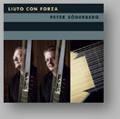>>Buy the record
Title:Rot
Year of comp:1999
Instrumentation:f slagverk
Duration:11
Premiered: 2000-04-30
Place: Stockholm, Musikmuseet
Performers: Jonny Axelsson
Title: Rotor
Year of comp: 1999
Instrumentation:p clarinetto
Duration:10´
Premiered:1999-10-02
Place:Stockholm, Moderna museet
Performers:Staffan Mårtensson
Title:Rotor II
Year of comp:1999
Instrumentation:p percussione e trombone
Duration:14´
Premiered:1999
Place:Stockholm, Musikmuseet
Performers:
Jonny Axelsson, Ivo Nilsson
Download a programme note
-as a word file (in Swedish)
-as a pdf file (in Swedish)
Title: Rotor zero
Year of comp:1999
Instrumentation: f trombon
Duration:9´
Premiered: 2000
Place: Odessa, 2 Days & 2 Nights
Performer:Ivo Nilsson
Download a programme note
-as a pdf file (in English)
-as a pdf file (in Swedish)
>>Watch video
Rotor zero is recorded on the Phono Suecia cd PSCD 132:
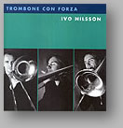>>Buy the record
Title: Pedal
Year of comp: 1999
Instrumentation: f flöjt/picc/a-fl, slagverk, orgel
Duration: 9´
Premiered: 1999-09-11 Place: Växjö domkyrka
Performers: Michael Pettersson, Daniel Berg, Bengt Tribukait
Title:Tre equale
Year of comp: 1998
Instrumentation: p chitarra, vibrafono e trombone
Premiered: 1998-08-23
Place: Kilkenny Arts Week
Performers: Magnus Andersson, Jonny Axelsson, Ivo Nilsson
Download a programme note
-as a word file (in English and Swedish)
-as a pdf file (in English and Swedish)
Tre equale is recorded on the Nosag Records cd NOSAGCD 117:
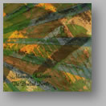>>Buy the record
Title: Deaf-mute
Year of comp: 1997
Instrumentation: f percussion and trombone
Duration: 12`
Premiered: 1998-05-20
Place: Gent, Stichting Logos
Performers:
Ivo Nilsson, Jonny Axelsson
Title: ¿Lo mismo?
Year of composition:1996
Instrumentation:para dos pianos
Duration: 11´
Year of publication: 1999-03-31
Place of first performance: Leipzig, Gewandhaus
Ensemble: Mats Persson, Kristine Scholz
Download a programme note
-as a word file (in English)
-as a pdf file (in English)
¿Lo mismo? is recorded on the Phono Suecia cd PSCD 106:
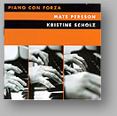>>Buy the record
Title:Mouth
Year of comp:1989/1991
Instrumentation: f embouchure and live-electronics
Duration: 7´30”
Premiered: 1991-12-07
Place:Stockholm, Radiohuset
Performers:
Ivo Nilsson

Title: Puls
Year of comp:1988/1992
Instrumentation:f piano
Duration:6´
Premiered: 1990-05-29
Place: Riddarhuset, Stockholm
Performers:Love Derwinger
Puls is recorded on the Daphne records cd DAPHNECD 1012:
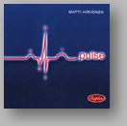>>Buy the record
Title: Nerv
Year of comp:1988/1991
Instrumentation: f cello solo
Duration:7´
Premiered:1992-01-25
Place: Stockholm, Mälargalleriet
Performers: Åsa Åkerberg
Title:ma lento
Year of comp:1994-1995
Instrumentation:p quartetto di flauti dolci (a,2t,b/s)
Duration:7´
Premiered: 1996-08-22
Place: Stockholm, Waldemarsudde
Performers: Svenska blockflöjtskvartetten
------------------

ivo.nilsson.com

